**Practical 12(Animation)**

**Question 1**

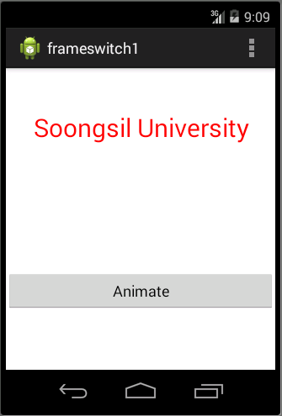

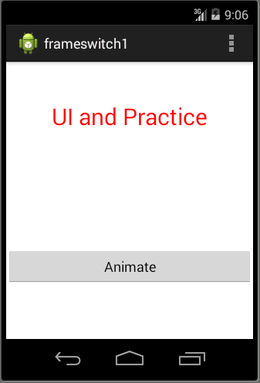

1. Your **activity_main.xml** file should have something similar to xml below: **(p/s: You do not need to follow the xml as it might be different in each design.)**

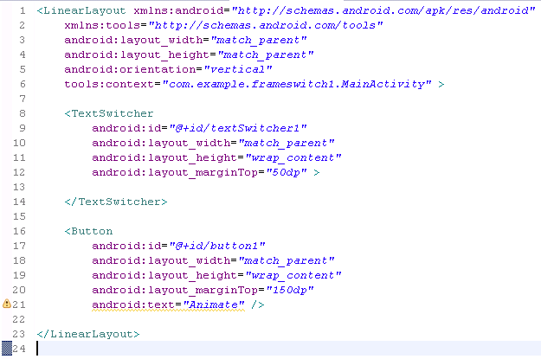



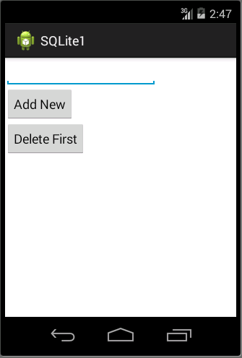

1. In your **MainActivity.java**, code the following code segment.

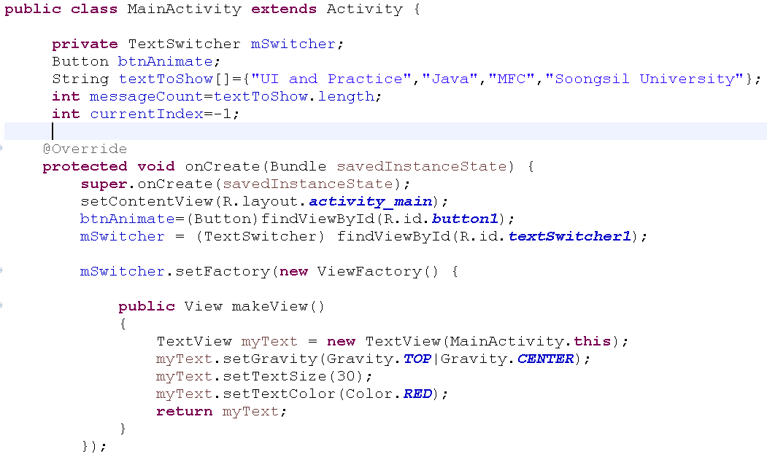

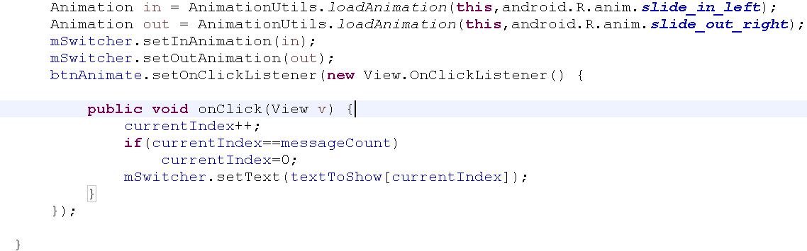

1. After make sure all the coding appropriate done, you may compile and run your coding .

**Question 3**

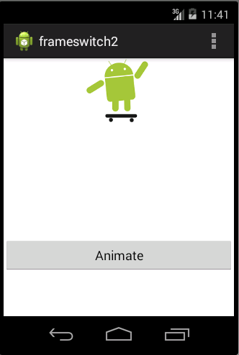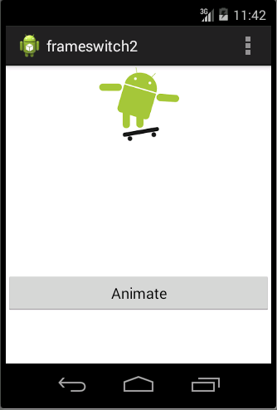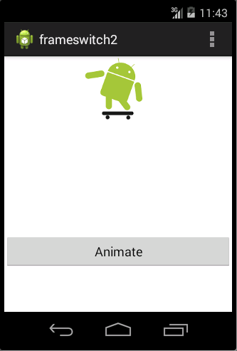

1. Your **activity_main.xml** file should have something similar to xml below: **(p/s: You do not need to follow the xml as it might be different in each design.)**

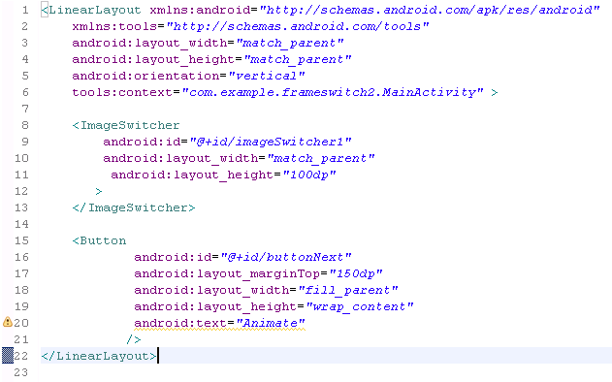



1. In the MainActivity, override the OnCreate().

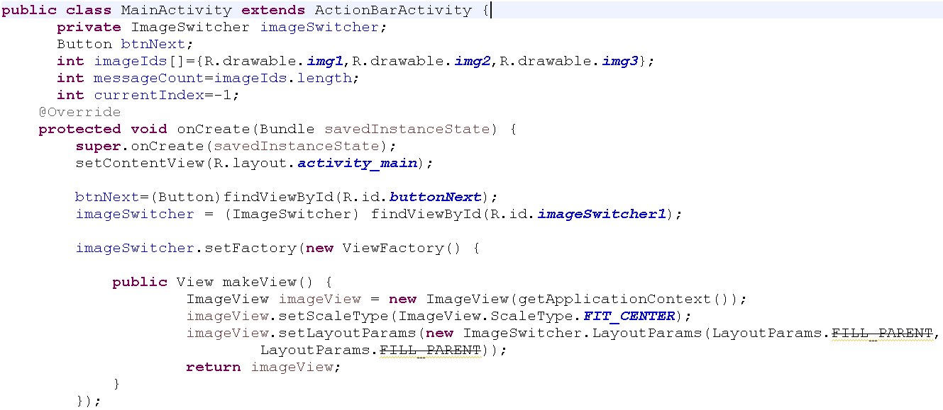

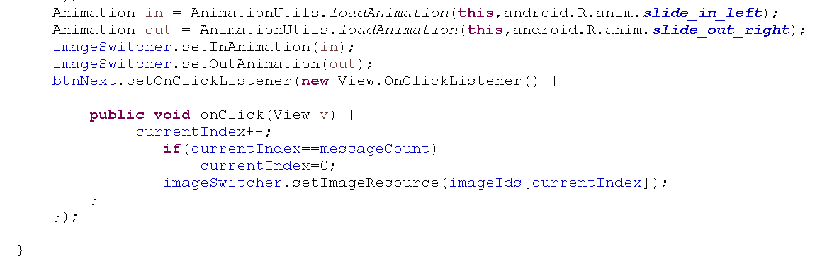

1. After make sure all the coding appropriate done, you may compile and run your coding .

**Question 3(Animation)**

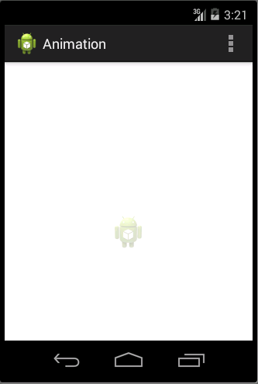

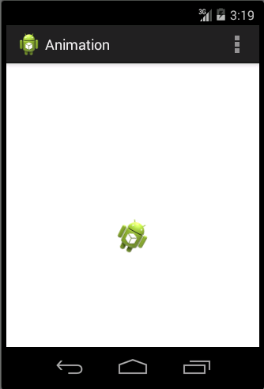

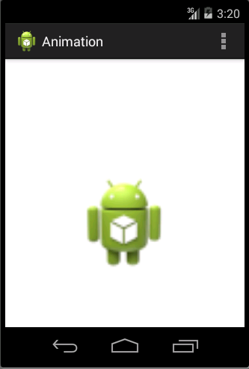

1. In your **/res/anim/** folder, create a **zooming.xml**

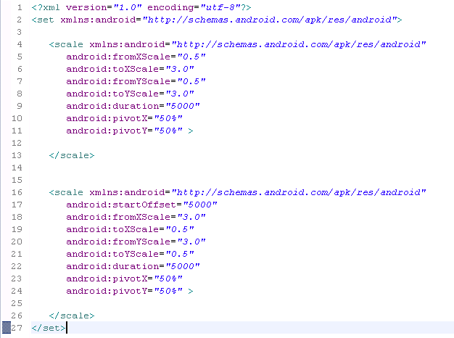

1. In your **/res/anim/** folder, create a **fade.xml**

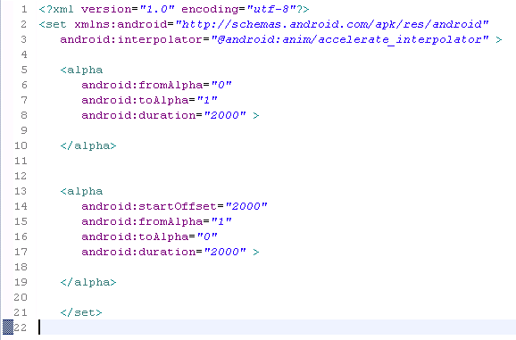

1. In your **/res/anim/** folder, create a **clockwise.xml**

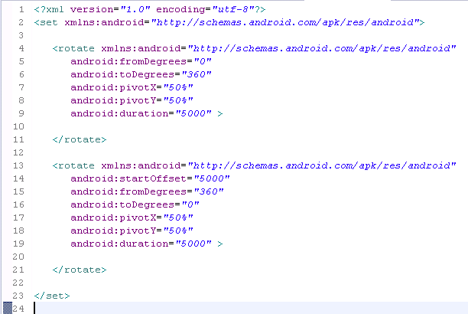

1. In your activity_main.xml

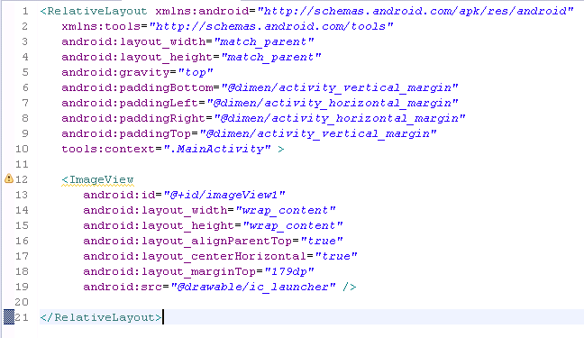

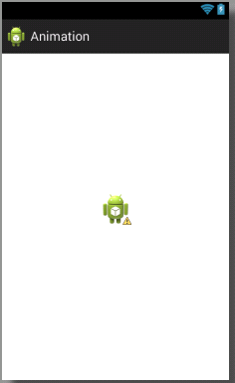

1. In your /res/menu/main.xml, perform the following for your menu.

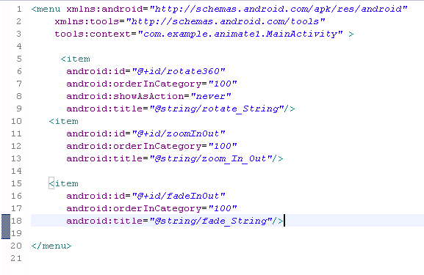

1. In the MainActivity, override the onOptionsItemSelected().

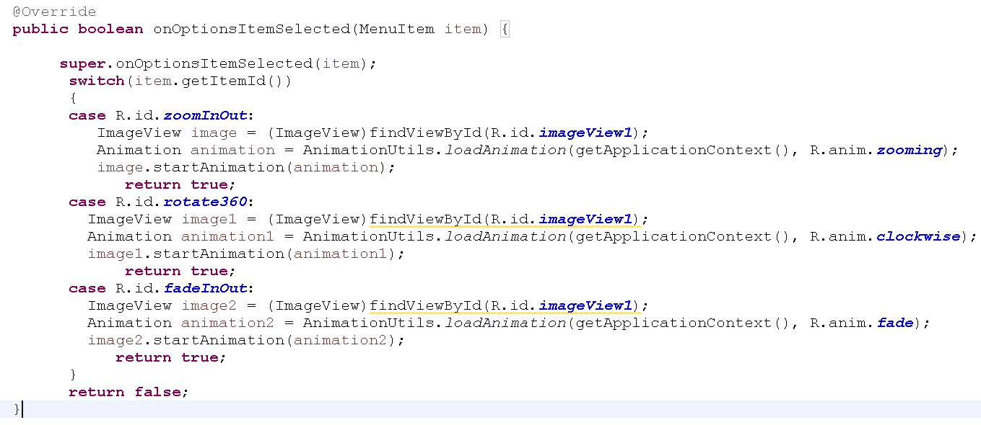

**Question 4 (Animation on button)**

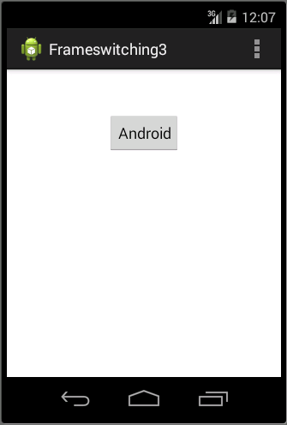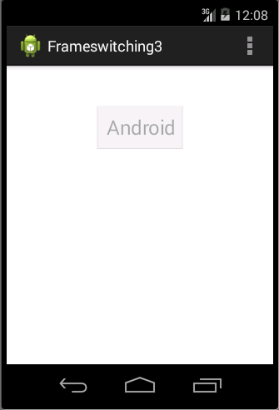

Create the Tween animation on a button. You may use any Tween animation from last practical class. You may also try to show the animation on other types of object on android.